Login to Azure portal And navigate the VM which you want to resize

You can see the current size of VM as B2s .

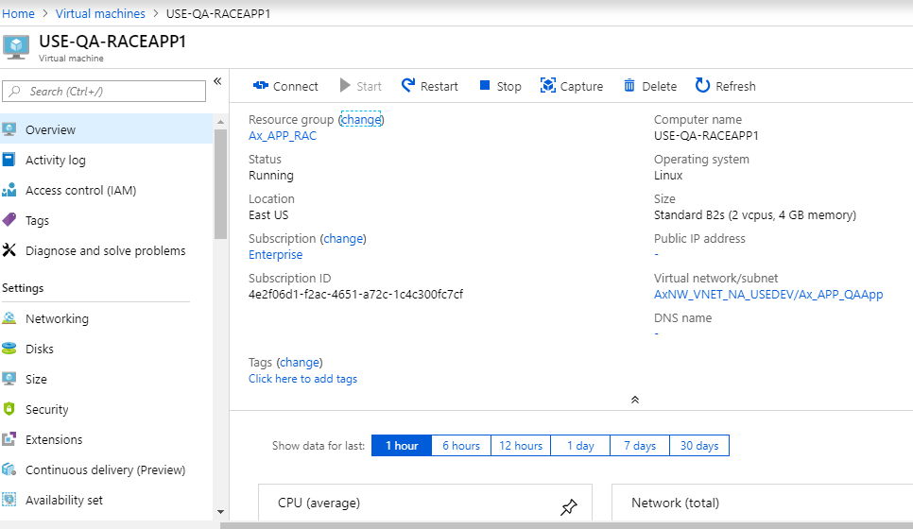

Select the Size option there you will find the All available size

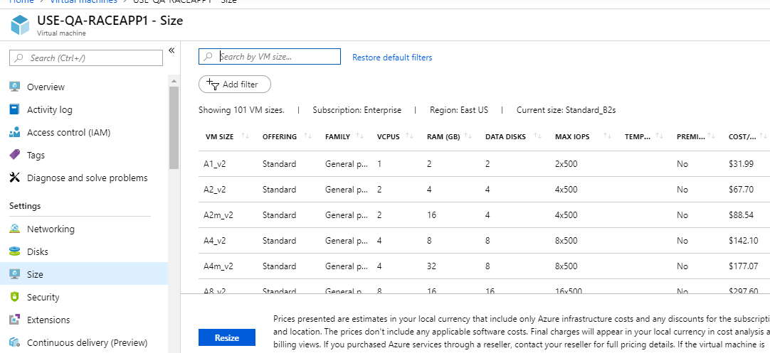

Select the size and click on resize

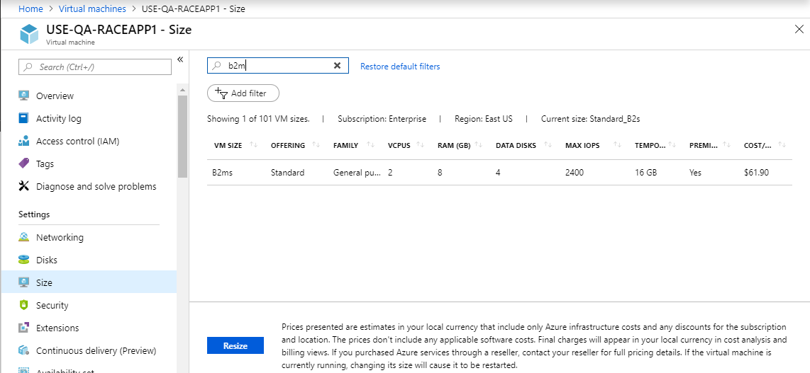

Go to overview you can see the size has been change b2ms

